

UNIVERSITY OF NAIROBI

School of Engineering

Department of Geospatial and Space Technology

UNIT: WEB-BASED MAPPING

COURSE CODE: FGS 6221

YEAR OF STUDY: II

TITLE OF THE TERM-PAPER: WEB MAPPING OF THE SEA LEVEL RISE IN MOMBASA ISLAND.

**NAME:** MURITHI FAITH KAGENI

**REGISTRATION NUMBER:** F56/42449/2022

**Introduction**

Sea level is a critical indicator of Earth's environmental health, as a barometer for global climate changes and human activities. It refers to the average ocean surface height measured relative to a specific reference point, usually the land. Over the past century, sea levels have risen at an accelerated pace, raising concerns among scientists, policymakers, and communities worldwide.

Mombasa Island, located along the eastern coast of Kenya, is a region particularly vulnerable to the impacts of sea level rise. As global temperatures continue to increase, the melting of ice caps, thermal expansion of seawater, and changing weather patterns contribute to rising sea levels that significantly threaten coastal areas worldwide.

The expected sea level rise varies depending on various factors such as the rate of greenhouse gas emissions, global climate policies, and the response of ice sheets and glaciers to warming temperatures. However, projections generally indicate that sea levels will continue to rise over the coming decades.

Estimates suggest that global sea levels could rise by anywhere from 0.3 to 1.3 meters (1 to 4 feet) by the year 2100 under different emission scenarios outlined by the Intergovernmental Panel on Climate Change (IPCC). For shorter timeframes like 50 years, estimates can vary, but a rough approximation might suggest a rise of several inches to around a foot or more, depending on the rate of emissions and other factors.

In this case, study I have compiled a flood risk web map of Mombasa Island if sea levels were to rise from about 1 metre to an extreme scenario of 20 metres above the current sea level using both QGIS and ArcGIS to do analysis and other data editing processes.

**Objectives**

1. Analyze the sea level rise from 1metre to 20 metre in the Mombasa Island.
2. Create an open layer of the Sea Level Rise.

**Methodology Employed**

The following steps were followed to model the flood risk map for Mombasa Island.

1. Acquisition of datasets for the analysis i.e. a Shuttle Radar Topography Mission (SRTM) 30 metres Digital Terrain Model (DEM) imagery of Kenya from the Regional Centre for Mapping of Resources for Development (RCMRD) open data site.
2. Cropping the imagery to Mombasa Island (Area of Interest).
3. Generating contours from the DEM.
4. Analysis of flooding risk that would occur under different sea level rises from 1 metre to 20 metres.
5. Generating layers for each level analysed.
6. Compiling and designing the web map.
7. Generating the web map in QGIS using the qgis2web plugin.

Below are screenshots of various sea level rise scenarios

|  |
| --- |
|  |

Given a 1 m sea level rise, an approx. area of about 0.30 km2 (2%) of land would be submerged or flooded. With Mombasa Island having a population density of about 10,543 people km2, that would translate to about 3,214 people being affected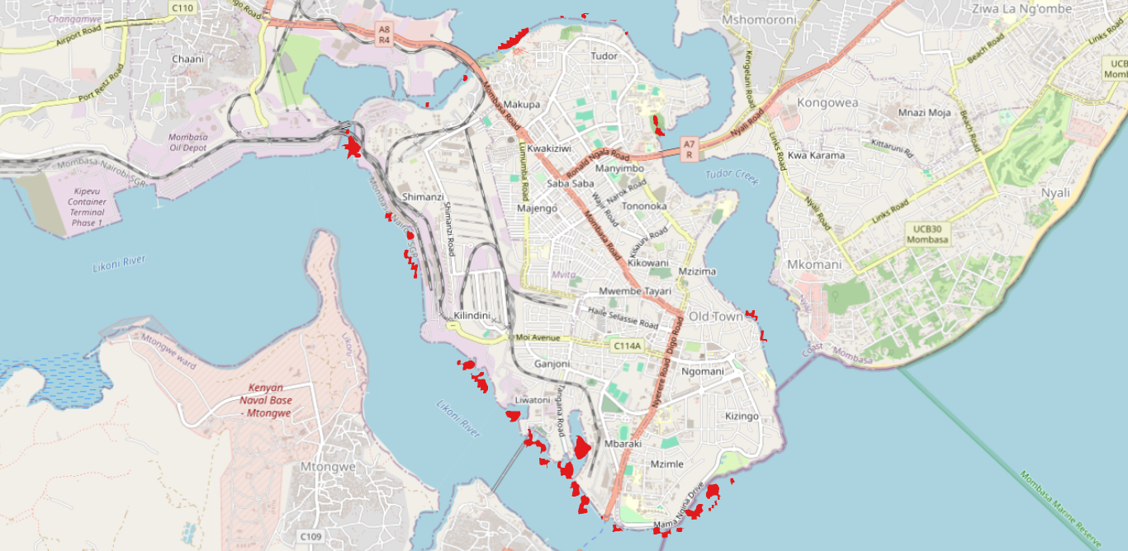

Figure 1: 1 metre sea level rise

|  |
| --- |
|  |

Given a 4 m sea level rise, an approx. area of about 1.05 km2 (7%) of land would be submerged or flooded. With Mombasa Island having a population density of about 10,543 people km2, that would translate to about 11,121 people being affected.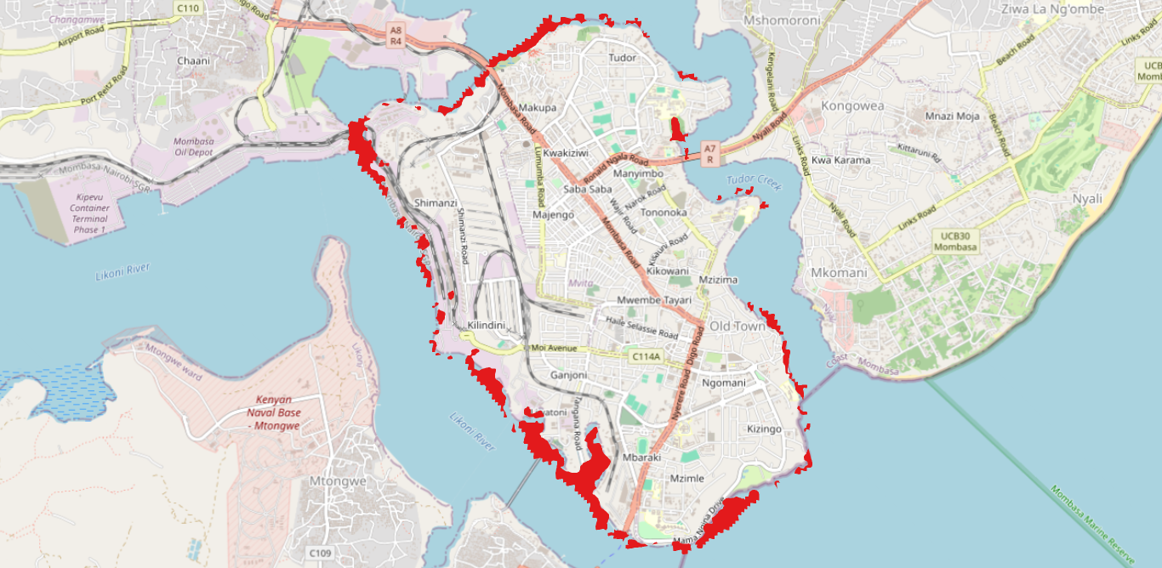

Figure 2: 4 metres sea level rise

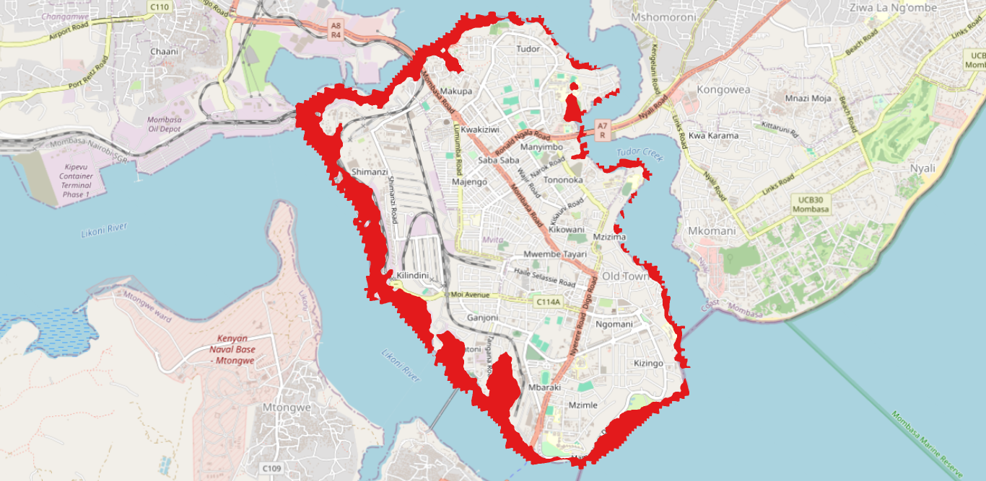Given a 10 m sea level rise, an approx. area of about 2.62 km2 (18%) of land would be submerged or flooded. With Mombasa Island having a population density of about 10,543 people km2, that would translate to about 27,640 people being affected.

Figure 3: 10 metres sea level rise

**Functionalities of the Web Map**

1. Measure length and area
2. Geolocation
3. Open Street Map base
4. Search function
5. Zoom function
6. Toggle layers

**Challenges Faced by Mombasa Island:**

* Geographic Vulnerability: Mombasa Island's geographical location makes it susceptible to the effects of sea level rise. As a low-lying coastal area, even a modest increase in sea levels can lead to inundation and increased vulnerability to storm surges.
* Economic Implications: The island is a vital economic hub for Kenya, hosting a major seaport and various industries. Sea level rise can disrupt port operations, damage infrastructure, and threaten the livelihoods of those dependent on coastal activities, impacting the broader economy.
* Threats to Biodiversity: Mombasa Island is rich in biodiversity, including coastal ecosystems like mangroves and coral reefs. Rising sea levels can lead to saltwater intrusion, affecting these delicate ecosystems and threatening the diverse marine life that relies on them.

**Local Impacts of Sea Level Rise.**

* Coastal Erosion: The coastline of Mombasa Island is experiencing accelerated erosion due to rising sea levels. This erosion jeopardizes beaches, hotels, and residential areas, leading to the loss of valuable land and impacting the tourism industry.
* Saltwater Intrusion: Sea level rise contributes to saltwater intrusion into freshwater aquifers. This poses a serious threat to the availability of potable water for the island's residents and can harm agricultural productivity in the surrounding areas.
* Infrastructure Vulnerability: Key infrastructure, including roads, bridges, and buildings, is at risk of damage from the encroaching sea. The deterioration of infrastructure can disrupt transportation, commerce, and essential services, exacerbating the social and economic impacts of sea level rise.

**Strategies for Resilience.**

* Adaptive Urban Planning: Mombasa Island must implement adaptive urban planning strategies considering projected sea level rise. This includes elevating critical infrastructure, constructing resilient buildings, and developing zoning regulations that discourage construction in high-risk areas.
* Mangrove Restoration: Mangroves play a crucial role in protecting coastlines from erosion and storm surges. Investing in mangrove restoration projects can enhance the island's natural defences, providing a buffer against the impacts of rising sea levels.
* Community Engagement and Education: Building resilience requires the active participation of local communities. Engaging residents in awareness campaigns, educational programs, and participatory decision-making processes can foster a sense of ownership and empowerment in addressing sea level rise challenges.

**Conclusion**

In conclusion, the issue of sea level rise in Mombasa presents a multifaceted challenge with far-reaching implications for the city's residents, infrastructure, and environment. As the global climate continues to change, exacerbated by human activities, Mombasa faces the threat of more frequent and severe flooding, erosion of coastal areas, and contamination of freshwater sources. Urgent action is needed to mitigate these impacts through measures such as coastal defence infrastructure, sustainable urban planning, and international cooperation to reduce greenhouse gas emissions. Additionally, community resilience-building efforts and adaptation strategies are essential to safeguarding the well-being and livelihoods of those most vulnerable to the effects of rising sea levels. By prioritizing proactive and collaborative approaches, Mombasa can strive towards a more resilient and sustainable future in the face of this pressing challenge.